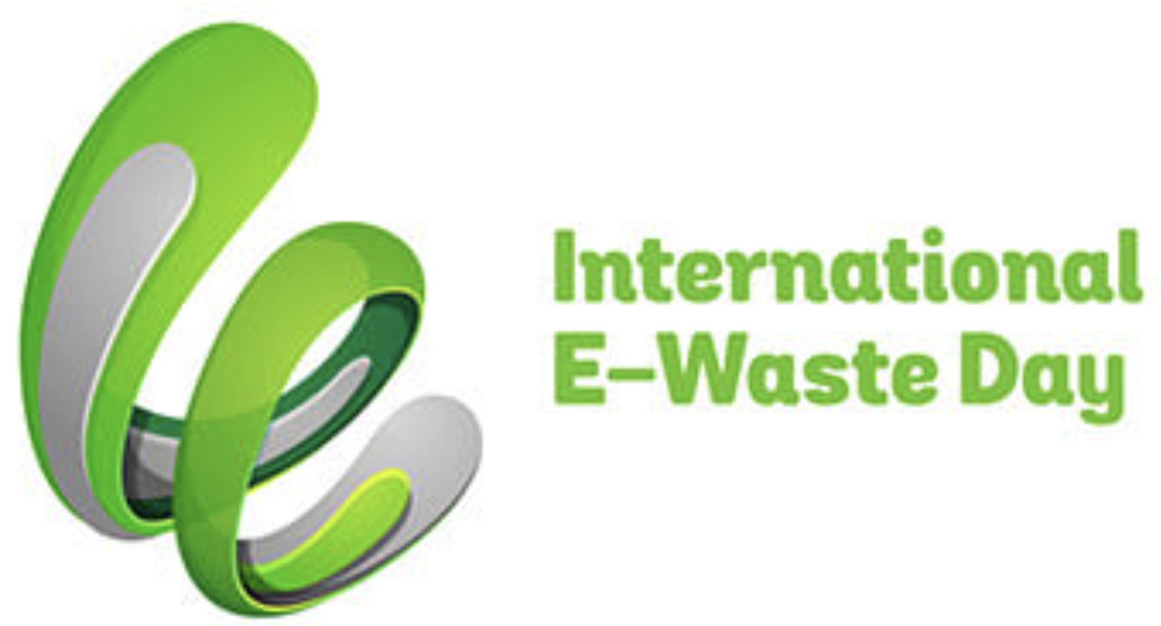

International E-Waste Day (#ewasteday): Thursday, October 14

For release: Wednesday, 13 October, 2021
10h:00 US EDT / 14h:00 GMT / 15h:00 UK Summer Time / 16h:00 CEST (to confirm local time, click here: https://bit.ly/3yWmgPV)

Media contacts: Terry Collins, +1-416-878-8712 (m), tc@tca.tc
Magdelena Charytanowicz, +32 2 7068703; +32 494 23 28 83 (m), magdalena.charytanowicz@weee-forum.org

e-Waste experts are available for advance interviews.
They will also take part in a news videoconference Wednesday, 13 October, 2021
10h:00 US EDT / 14h:01 GMT / 15h:01 UK Summer Time / 16h:01 CEST
To join: https://us02web.zoom.us/j/8935863496; or dial +1-929-205-6099, ID: 893 586 3496
International E-Waste Day website: weee-forum.org/iewd-about
Photos: https://bit.ly/3AfySSM

International E-Waste Day:
57.4M Tonnes Expected in 2021
Will Outweigh China’s Great Wall

The online streaming explosion: an emerging e-waste concern, and information gap

On International E-Waste Day 2021, leading experts and producer responsibility organisations are calling on households, businesses and governments to get behind efforts to get more dead or unused plug-in or battery-operated products to facilities where they can be either repaired or recycled to recover a king’s fortune in valuable materials and reduce the need for new resources.
This year’s worldwide mountain of waste electronic and electrical equipment (WEEE) will total an estimated 57.4 million tonnes -- greater than the weight of the Great Wall of China, Earth’s heaviest artificial object.
Last year’s Global E-waste Monitor 2020 reported that an estimated 53.6 million metric tonnes (Mt) of WEEE was generated in 2019. That represented a 21% jump in the five years since 2014 (with e-waste on a predicted course to 74 Mt by 2030).
Global e-waste generation is therefore growing annually by 2 Mt, or about 3 to 4%, a problem attributed to higher consumption rates of electronics (increasing 3% annually), shorter product lifecycles and limited repair options.
According to estimates in Europe, where the problem is best studied, 11 of 72 electronic items in an average household are no longer in use or are broken. Annually per citizen, another 4 to 5 kg of unused electrical and electronic products are hoarded in Europe prior to being discarded.
When it comes to mobile phones, a French study estimates that 54 to 113 million mobile phones alone, weighing 10 to 20 tonnes, are sleeping in drawers and other storage spaces in French homes.
In the US, while many mobile phones are recycled, an estimated 151 million or more phones a year -- approximately 416,000 a day -- are trashed and end up incinerated or landfilled, and that 40% of heavy metals in US landfills come from discarded electronics.
By weight, discarded big appliances such as stoves and refrigerators constitute the largest component of e-waste. These large appliances contain steel, copper and aluminium which makes them attractive to thieves. Despite concerted efforts by governments at many levels, this problem persists. Even in the EU, which has had comprehensive Extended Producer Responsibility (EPR) legislation in place for nearly two decades, consisting of targets and legal responsibilities, the EU’s formal e-waste collection rate is 55% (2018). Huge progress has been made in the last 20 years, but member states still struggle to achieve the targets for many complex reasons, as documented by UNITAR and the Brussels-based WEEE Forum in a report, WEEE Flows study and vision.
Says Pascal Leroy, Director General of the WEEE Forum, the organisation behind International E-Waste Day: “Many factors play a role in making the electrical and electronics sector resource efficient and circular. For example, our member producer responsibility organisations collected and secured responsible recycling of 2.8 Mt of e-waste in 2020. But one thing stands out: as long as citizens don’t return their used, broken gear, sell it, or donate it, we will need to continue mining all-new materials causing great environmental damage.”
“This year’s focus for International E-Waste Day is the crucial role each of us has in making circularity a reality for e-products. This is more important than ever as our Governments go into COP26 to discuss global action to reduce carbon emissions. Every tonne of WEEE recycled avoids around 2 tonnes of CO2 emissions. If we all do the right thing with our e-waste we help to reduce harmful CO2 emissions.”
Hoarding, and the failure to return EEE
When asked about recycling rates, members of the public estimate that 40-50% of e-waste is recycled (illustrated by interviews at https://bit.ly/3FtNPoj, available from 14 October). In fact, less than half that -- 17.4% -- was known to be properly treated and recycled in 2019.
In the case of cell phones, tablets, computers and other small information technology products, many factors are thought to discourage recycling, including data security, product value, difficult-to-reach return points, and uncertainty about appropriate recycling, among others.
Says Ruediger Kuehr, Director of the SCYCLE Programme and Head of UNITAR’s Office in Bonn, the value of EEE components in the world’s 'urban mines' is enormous.
“A tonne of discarded mobile phones is richer in gold than a tonne of gold ore,” Dr. Kuehr points out.
“Embedded in 1 million cell phones, for example, are 24 kg of gold, 16,000 kg of copper, 350 kg of silver, and 14 kg of palladium -- resources that could be recovered and returned to the production cycle. And if we fail to recycle these materials, new supplies need to be mined, harming the environment.”
“Moreover, the recovery of gold and other material from waste saves a lot of carbon dioxide emissions when compared with virgin metal mining,” says Kees Baldé, Senior Programme Officer of the UN University’s SCYCLE Programme.
He adds that high-value, recoverable materials conservatively valued at US $57 billion -- a sum greater than the Gross Domestic Product of most countries – were mostly dumped or burned in those parts of the world without extended producer responsibility legislation in 2019 rather than being collected for treatment and reuse.
Successfully raising collection rates requires every actor to be involved, including consumers.
“Alongside convenience, financial compensation, care for the environment, culture and social norms, awareness is one of the key motivators for people to take action on e-waste,” says Magdalena Charytanowicz of the WEEE Forum in charge of International E-Waste Day.
“This is why on 14 October we hope to reach as many citizens worldwide as possible and urge the proper disposal of end-of-life electronics by encouraging campaigns and awareness activities such as e-waste collections, school lectures, and social media outreach. Even the smallest action promoting sound e-waste collection, repair, reuse or recycling is welcome in the frame of International E-Waste Day.”
“Consumers,” she adds, “want to do the right thing but need to be adequately informed and a convenient infrastructure should be easily available to them so that disposing of e-waste correctly becomes the social norm in communities.”
E-waste and the Internet: An information gap
An emerging dimension of the e-waste issue: rising world demand for data and digital services.
A recent European report (at https://bit.ly/3A9gzyC) says that “video on demand, movies, social media clips and game streaming take up close to 85% of the bandwidth of the data centres.”
Meanwhile, a 2020 joint ITU and WEEE Forum study (at https://bit.ly/3o5pRcz) underlines that digitalisation is needed to foster economic circularity. It also includes several startling statistics. For example:
- Internet users have doubled since 2010, traffic has grown approximately 30% annually, and by 2023 users worldwide will number 5.3 billion (66% of the world’s population).
- Mobile Internet users are projected to increase from 3.8 billion in 2019 to 5 billion by 2025 while IoT-connected devices will double from 12 billion to 25 billion in that same period.
All this and the dawning uses of cloud computing, 5G, self-driving cars, blockchain, machine learning and other areas of artificial intelligence require an ever-growing number of servers -- millions of them in data centres.
While this type of professional equipment for Internet connectivity certainly represents far less e-waste by weight than consumer devices, the report notes, there is very little hard data available -- an information gap that needs to be filled.
Adds the report: “Smartphones continue to be at the centre of data use growth, as they generate most of the mobile data traffic (95% projected in 2025). Traffic growth is driven both by the rising number of smartphone subscriptions and increasing average data volume per subscription, fuelled primarily by higher resolution video content viewing.”
And product manufacturers have a major role to play alongside that of consumers.
“Fast mobile phone development has led to a market dependency on rapid replacement of older devices. Mobile devices affect the environment in many ways over their lifetimes, but the impact can be reduced and spread over a longer period by applying circular economy principles, including production control, device reuse, remanufacture and recycling, and improved circular design involving component material selection, standardization and modularization for easier disassembly.”
* * * * *
About

International e-Waste Day (#ewasteday)

Last year over 120 organisations from 50 countries worldwide supported the third International e-Waste Day observance. This year, the WEEE Forum and other organizers invite all organisations involved in effective and responsible e-waste management to plan awareness raising activities.
www.internationalewasteday.com

The WEEE Forum
The WEEE Forum is a Brussels-based for-impact, not-for-profit international association representing forty-five producer responsibility organisations across the globe. Together with our members, we are at the forefront of turning the extended producer responsibility principle into an effective electronic waste management policy approach through our combined knowledge of the technical, business and operational aspects of collection, logistics, de-pollution, processing, preparing for reuse and reporting of e-waste. It is the biggest organisation of its kind in the world. Our mission is to be the world’s foremost e-waste competence centre excelling in the implementation of the circularity principle. The PROs are based in Europe, the Americas, Africa, Oceania and Asia. In 2020, its member organisations reported collection and proper de-pollution and recycling of 2.8 Mt of WEEE. Website: www.weee-forum.org. Correspondence pascal.leroy@weee-forum.org
* * * * *

